26th March 2020

Dear Families

Once again thank you for your support through this difficult week and for all the positive comments that we have received. I would like to thank all the staff for ensuring that we can offer childcare for our critical workers. We hope that this has made things a little easier for all of you who are on the front line in this fight against the virus. Things are changing daily, and we are trying to adapt to your needs as these changes happen. We will continue with the childcare arrangements as they have been this week for next week. You should have received a letter about the arrangements for the Easter break yesterday.

FSM vouchers
We are trying to order vouchers from Tesco for families who are eligible for Free School Meals. It has not been a simple process but we will let you know when the codes are ready to send out. This will come as an e card that will be personal to you. It will be for the two weeks starting Monday 23rd March until we would have broken up for the Easter break (3rd April).

Easter
SCL will run a provision at three of our sites – Hale, Holly Lodge and The Grove. The Trust will pay for this so there will be no cost to keyworker families. Please note that this is only for keyworker families and not our vulnerable children or those with an EHCP. Depending on any new advice, we are planning to reopen our school provision after the Easter break to families who are currently eligible. If you are a keyworker and have managed childcare to date, please can you email chidcare@kite.academy so that you are included in the mailing of the flier.
If the need for key workers escalates over the Easter period and you need to request provision for your child/children at the last minute we may be able accommodate you and will share the means to do this towards the end of next week.

Yours sincerely
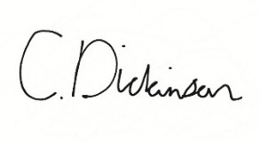

Christine Dickinson
CEO The Kite Academy Trust

