23rd March 2020

Dear Families
Thank you for your support by keeping your child at home if it was at all possible. We were pleased that the numbers were fairly low in all of our schools. The government were very clear that keyworkers should only use this facility if it was absolutely necessary. We are all trying to self-distance and for the sake of our children and staff we want to keep social contact to a minimum.
Our booking service via Tucasi is ready for everyone to use for tomorrow and onwards. You should have received a link to this. It is important that you register for a place so that we can plan for the appropriate numbers of staff to be available on our staff rota. You will be assured of a place if it is booked unless we contact you. Please could you book any places from tomorrow even if you have already asked for one through the email. This will help us to keep it all in one place. If you have not received a link for the online system and believe that you are entitled to access the key worker childcare, please email childcare@kite.academy to request that the link is sent to you. You will need to give your child’s name, academy and your occupation.
Parents are welcome to book in their child for all or part of a session, depending on their shift pattern. We aim to keep the number of staff needed to a minimum as much as possible.
Lunches will be available from tomorrow in our academies that are open. We are also trying to get information about how our families can access vouchers if their child qualifies for free school meals.

Yours sincerely
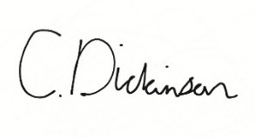

Christine Dickinson
CEO The Kite Academy Trust

